The Halftimes
Villa Marie End of Year Newspaper
Hello! This is the third edition of The Halftimes. I can’t believe I’m making the third one already! It’s been an exciting year already, with more to come. We have the Art Awards, Bishop Conley’s visit in April, and we are having four graduates this year! We also have a special interview with our new development director and a poetry contest. I’m so excited to continue my newspaper and I hope you will enjoy reading this one as much as the others.

Pictures from our year

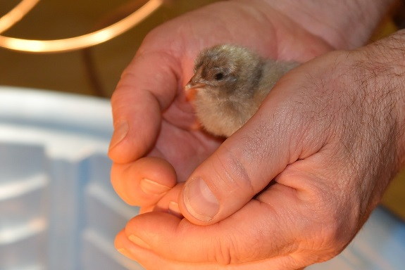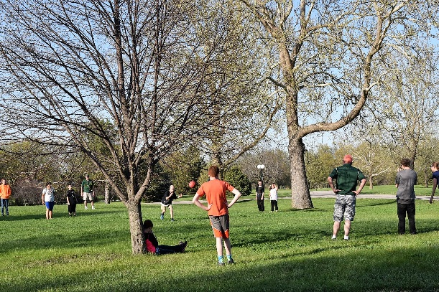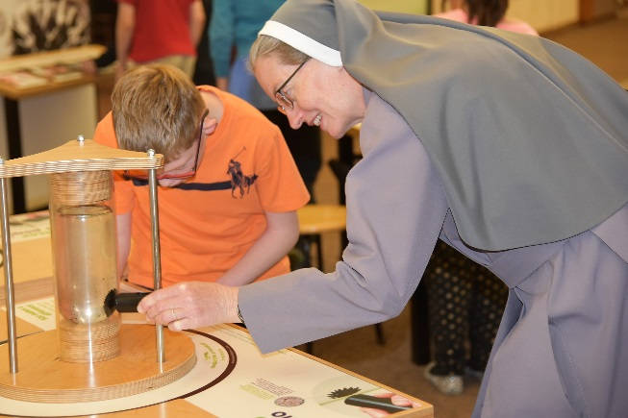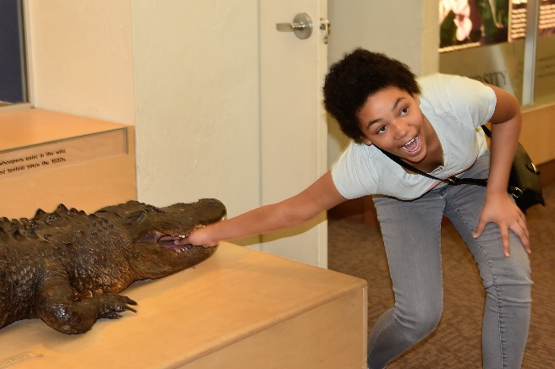
Interview with Villa Marie Development director Jenny Allamby
By Lillia
Lillia: So what does a development director do?
Jenny: They develop relationships. I meet with people and I do a lot of marketing to promote the school. I want people to think big, I try to build their enthusiasm so that they will partner with us and find out what their passionate about, and then try to match it to the needs of the school. I’m here to build a future for the kids and to find out what they need.
L: How did you find out about Villa Marie?
J: I interviewed with Fr. Meysenburg for some positions at Pius. One of our board members, Nick, contacted Fr. Meysenburg to see if he had interviewed anyone for Pius that would be a good fit for Villa Marie. And then Fr. Meysenburg e-mailed me and sent me all kinds of information about Villa Marie. So then I sent my resume and cover letter to Nick.
L: What did you think when you first came here?
J: I came for a visit, if you remember, and I was really, really nervous because I had never met a nun before. When I came, I felt welcomed immediately, because the kids were so precious. Jasper helped me through Mass, and it had been my first time at Mass since a funeral I went to. I could feel that this place was just surrounded by love, and people really cared about each other. I was kind of nervous about not being Catholic and being in an environment I was unfamiliar with. It was wonderful, and I loved it. I left hoping they would hire me because I thought it would be a good fit.
L: How do you feel about working around all the students?
J: I love working with you guys around me. I love when I come in the morning and see your smiling faces because you’re so happy to see me. I love walking around, looking at what you’re doing. It’s much better being in this environment, than in an office environment. There’s so much going on and it’s fun being around you kids. I think of you all as kind of like my kids. I see you every day, I even see you more than my kids!
L: What are your goals for the future of the school?
J: I have big, big dreams for Villa Marie. First and foremost, we need to get this school financially stable and secure. I’d like to see the school expand building-wise. If we had more space, we could help more kids and I’d like to be able to see us get the alumni more involved. We talked about alumni basketball and meetings. We’d like to have alumni come back and talk to you kids about what they are doing. Beyond that, I’d like to see something equivalent to a college for alumni. You would live in an apartment or group home and have opportunities. There were plans for such a place, with a dog kennel, flower shop, bakery, etc. I’d love to see a big auditorium, a new chapel, and even a place where we could cater events. We could give some vocational training to teach the skills necessary to be able to operate a business. During this transition period, they could develop friendships and then maybe get an apartment out in the community but still be connected to Villa Marie by possibly teaching the younger students vocational skills. So then they could give back to Villa Marie.
L: Are you ever tired or stressed out from working?
J: Yes. Part of my job is to look at the things that we have done the same way for the past fifty years and make suggestions to change or update the way we do them. It’s hard for me when people don’t like to change things when they’ve been doing for so long. What also stresses me out is when there’s a lot of noise, like when I’m trying to write something. One of the sisters found some noise-reducing headphones, so I’m hoping those will help me.
L: Do you enjoy working here?
J: I love it here. I know God’s hand was in all of this to bring me here. I’m so inspired by everything around me. I am grateful every day that I come to work to help make a better future for you kids.

Special Olympics
By Lillia
This year, our Special Olympics teams did wonderfully. At State Bowling, Mike got a silver medal, and Joshua got a gold medal for ramp bowling. The non-ramp bowlers, John and Sam, each got a silver medal.
Then, at the State Basketball Game, the Villa Marie Eagles got third. When they played the Madonna team, which was full of younger children, our team was very good about giving them a chance, passing the ball to them and the like. Last year we beat the Norris Titans and won the championship! We got a newly paved basketball court this year thanks to an anonymous donor.
And then there was the regional track meet. All three of the athletes participating in shot put each got first in their divisions! The running event were cancelled due to constant rain that made the track slippery. That meant everyone participating in running events automatically qualified to go to state.
We also got new uniforms thanks to Coach, Jenny, and many of their friends. They are white and blue, the colors of our school. They’re also reversible!

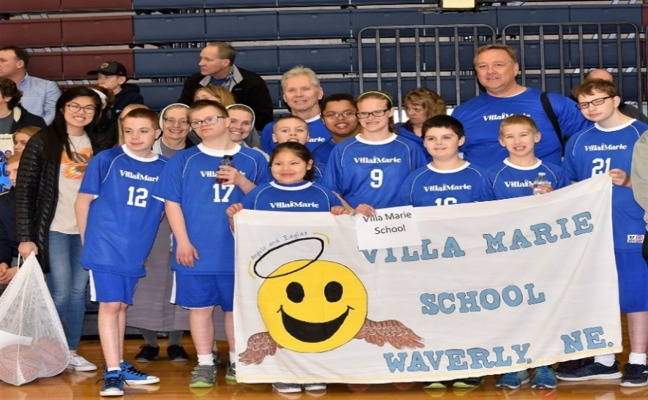
A potato flew around the room…

Bishop Conley’s Visit
By Ty

Bishop Conley came on April 12th to say Mass for us. Noah and Luke served at Mass, and Jamesha and Lillia did the readings. Fr. Clark and Msgr. Perkinton were at Mass, too.
After that, we had brunch. Msgr. Perkinton, Sr. Jeanette, Jenny, Jenny’s mother, Emma, Lexxus, and I sat at the head table with the Bishop. Matt, Lillia, Sapphire and Jamesha served us food and drinks. We talked about Basketball and our chickens. Afterwards, we gave him gifts, such as a bird feeder, peanuts, and a DVD of the Christmas Play. Finally, he gave us a blessing before leaving.
*********************************************
Poetry Contest
By Lillia
I’d like to thank all the students who entered their wonderful poetry for my contest. It was very hard to decide on the winners, but I have for you readers two beautiful poems written by two very creative students. I hope you love these as much as I did.

Roses are Red,
Violets are Blue,
I love poetry,
So here’s a poem for you.
-Mike Egr
Yoda’s Soda
There once was a person named Yoda,
Who liked to drive his Toyota.
He once got pulled over
By a dog named Rover.
He was driving too fast to his soda.
-Trenten Holeka

Art Awards
By Jamesha
The art awards were hosted this year on April 9th, by a group a women that are called Epsilon Sigma Alpha. They have been coming to Villa Marie since 1972. The art award winners were Coltin (Younger Division), Noah (Intermediate Division), and Emma (Older Division). They were really good! At the end of the art awards we had some snacks and drinks. The winners got $5 and the rest got $1 for being a participant. We each received a certificate, too.
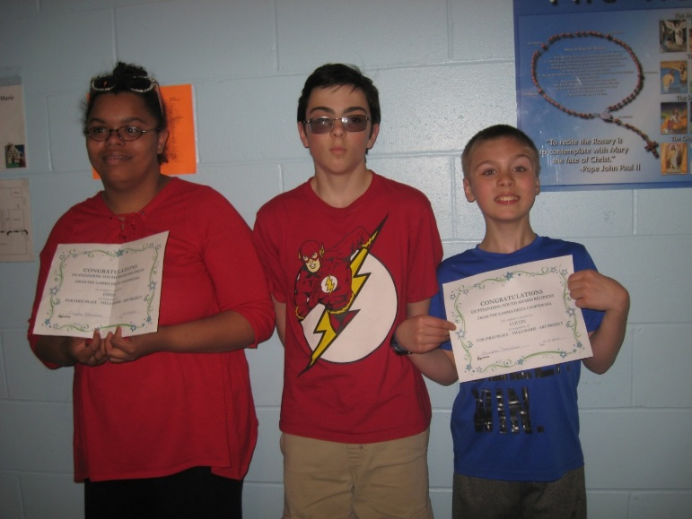

Graduation
By Sapphire
May 17, 2018 was a sad day at Villa Marie as we said goodbye to our four graduates: Ty, Kurtis, Emma, and Lexxus. They graduated that day at St. Patrick’s Church at 7:00 PM.
Each graduate gave a speech and received a diploma. The other students also received their own awards.
Msgr. Dawson was also there to give out the Msgr. Dawson Award.
Stay tuned for the next edition of the Halftimes, coming Christmas 2018!

Didn’t get a printed copy? Check out Villa Marie’s website for an online version at www.villamarieschool.com
Also check out the Facebook page!
Search Facebook: Villamariewaverly

